© Copyright Broadsword Interactive 1998

Physics
Description of the collision detection/resolution code

Jim Finnis (jcf@broadsword.demon.co.uk)
Revision: 1.4
NOTE – REVISION NUMBER CHANGED FROM 1.8 TO 1.4 TO FIT RCS SYSTEM

Created: 9/10/98
Last Revised: 19/11/98
Document State: Draft

Overview
The physics system is divided into two parts: collision detection and collision resolution. I will discuss the collision detection system only briefly, because it’s fairly simple, but I will discuss the resolution phase in more detail.

Essentially, the physics is impulse-based with a few hacks to get round some of the common problems associated with a purely impulse-based system without requiring a large amount of computational resources. “Impulse-based” means that each collision produces a instantaneous force – an impulse - which acts on the objects involved to correct the collision. There must then be a ‘recover’ stage, which ensures that the objects are no longer colliding, because (due to such factors as the coefficient of restitution) the impulse will always be insufficient to entirely correct the collision.

The Main Loop
Note that this document describes the physics as implemented in the Boris 1 test-bed, rather than the final code as re-implemented by Mark Vince, because the Boris 2 engine is fundamentally different from the Boris 1 engine. This document will be updated once that implementation is complete.

All the physics is invoked from the routine MovementTick in collision.cpp, which does the following:

while now < tickstart+PHYSC_TICK // now is the current time, tickstart is the time at the start of the tick
// and PHYSC_TICK is the length of a tick. now = tickstart at the beginning
// of this routine.
{
get soonest collision between now and tickstart+PHYSC_TICK // this actually returns a collision item
// with all the collision dat
if there isn’t one, break out of this loop

interval = time between now and this collision we just found

if interval < INTERVAL_THRESHOLD // this clause helps with microcollisions
{
Recover(collision item) // see below
move the time of the collision item forward to now+INTERVAL_THRESHOLD
}

RunPhysics(collision item, interval) // actually process the physics between now and the collision
// and then process the collision itself – see below

now = collision item time // advance time counter to this collision’s time
}

interval = (tickstart+PHYSC_TICK)-now // get the remaining time left in this tick

if interval>0 // if there’s any time left
{
RunPhysics(NULL,interval) // run the physics for the remainder of the tick with no
// collision
}

now = tickstart+PHYSC_TICK // advance the time counter to the start of the next tick

Collision Detection
The collision detection routines use a hull, stored in the model archives, which consists of spheres, lines and disks. To find a collision between a certain pair of time indices, the routine GetSoonestCollision is called, which returns a collision item. This contains all the relevant information about the collision including the object(s) involved, the triangle involved if this was a collision with a world triangle, and the time of the collision.

GetSoonestCollision works by calling GetObjectWorldCollision on each object and GetObjectObjectCollision on each pair of objects which are likely to collide (using a time-of-impact estimation system). Any collisions found within the time frame are added to a list of collision items, the soonest of which is found by scanning the list.

GetObjectWorldCollision and GetObjectObjectCollision themselves work by moving the object forward through the interval in n fixed steps (currently 5) until a collision is found. If none is found, no collision is returned. If a collision is found, a binary chop is done until a precise time for the collision can be determined. The collision details are then returned.

In order for objects to be ‘temporarily’ moved back and forth by the collision routines, two methods – SavePos and RestorePos – are used to save and restore the real position of the object before the collision test routines move it around.

Note that this process entails a large number of collision checks, so it’s important that the collision check routines are optimised. Using spheres, lines and disks as primitives means that the number of primitives checked for collision can be kept low.

RunPhysics
This routine processes the actual physics of the objects. It takes a time interval, indicating how long the physics should be run for, and an optional collision item if a collision should be applied.

It runs the RunPhysics method on each PhysObject in the world:

for each PhysObject
{
if there is a collision item, and this is the primary object involved
{
object->RunPhysics(interval,collision item)
}
else
{
object->RunPhysics(interval,NULL)
}
}

The RunPhysics method itself, combined with the Integrate method, is described below in mathematical terms.

Basic Concepts
If r is the position vector of a point on a body, ω is the angular velocity of the object around the centre of mass, then the angular component of the velocity of the point is:
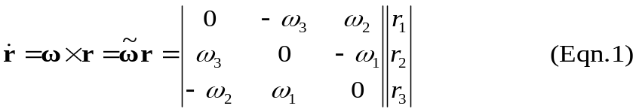

Since ω is the angular acceleration, and A is the orientation, we can effectively differentiate the orientation matrix by applying the skew-symmetric matrix shown above:

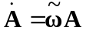

where A is the orientation matrix of the object. We can therefore do a simple numerical integration of the orientation over a time interval h using:

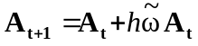

If the position vector of a point b relative to the origin of the body o is r, (i.e. r is b’s position in body space) then

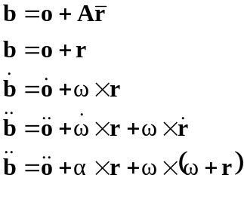 (Eqn. 2)
If we express angular momentum as a vector L_{AB}, meaning the angular momentum of B viewed from A, then (if p_{B} is the linear momentum of B and F_{AB} is the force) we can get the torque τ_{AB} using

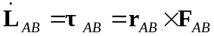 (Eqn. 3)

Now for the total angular momentum of the body, represented as L_{AT} (angular momentum of everything looking from point A).

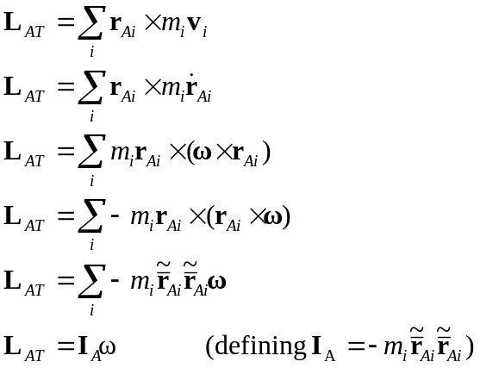 (Eqn. 4)

We can find the total torque in the body by summing the individual torques of the points:

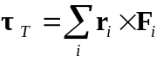 (Eqn. 5)
We can then get the momentum by integrating this over time (where h is the time interval and CM means “with respect to the centre of mass”):

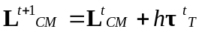 (Eqn. 6)

To get ω, the current angular velocity, we multiply the momentum by inverse of the tensor of moment of inertia (see Eqn. 4):

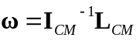 (Eqn. 7)

Using the Tensor of Moment of Inertia
This tensor changes with the orientation, so we need to find a way to recalculate the inverse inertial tensor each tick. If the inertial tensor in body space is (definition from Eqn. 4)

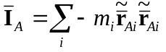
then we can calculate the inverse of this at the beginning, and similarity-transform this body-space tensor to world-space each tick using the orientation matrix:

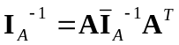

To calculate the tensor, we assume that the object is a cuboid of fixed density, whose centre of mass is the centroid of the cuboid. We can derive the following inverse inertia tensor:

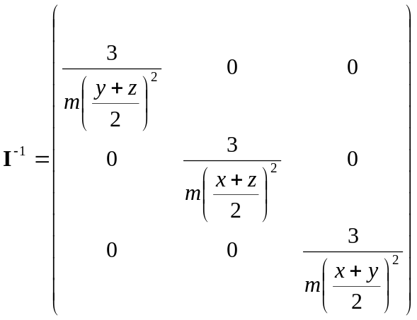

where x, y, z are the physical dimensions of the object and m is the mass of the object.

Initialisation of the Physical Properties

This is all done in the PhysObject::CalculatePhysicalProperties method.

Initialise the following quantities for each object:

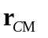 position of centre of mass, relative to world;
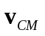 velocity of centre of mass;
 initial orientation matrix;
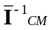 inverse of tensor of inertia in body space;
m mass;
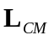 initial angular momentum vector;

Then calculate

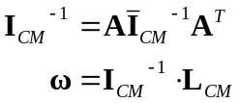

I_{CM}⁻¹ is the inverse of the tensor of inertial in world space, and ω is the angular velocity.

The Algorithm – Processing an Object’s Forces
This functionality is split between the RunPhysics and Integrate methods of the PhysObject class.

First, get all the forces acting on the object and the points upon which they act. Then calculate the total forces and torques (F_{i} represents force i, τ_{i} is the torque of the force at that point, and r_{i} is the position of the point relative to the centre of mass of the object:

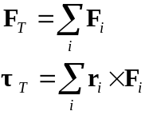
To work out the force for a collision, we also need to work out the magnitude of the collision impulse, if there is one.

For an object/object collision, the magnitude of the collision impulse for an object A is:

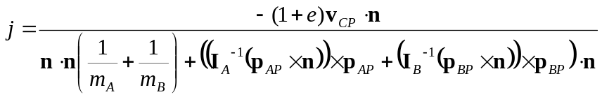

Where
v_{CP} is the relative velocity of the two objects at the point of collision
I_{A}⁻¹ is the inverse of the tensor of inertia in world-space for A
I_{B}⁻¹ is the inverse of the tensor of inertia in world-space for B
p_{AP} is the position of the collision point in A’s body-space
p_{BP} is the position of the collision point in B’s body-space
n is the normal vector for the collision

We can simplify this considerably in the case of object/world collisions, if we assume that the mass of the world in infinite. Since I_{B}⁻¹ will be a null matrix, and that a normal dotted with itself gives 1, then

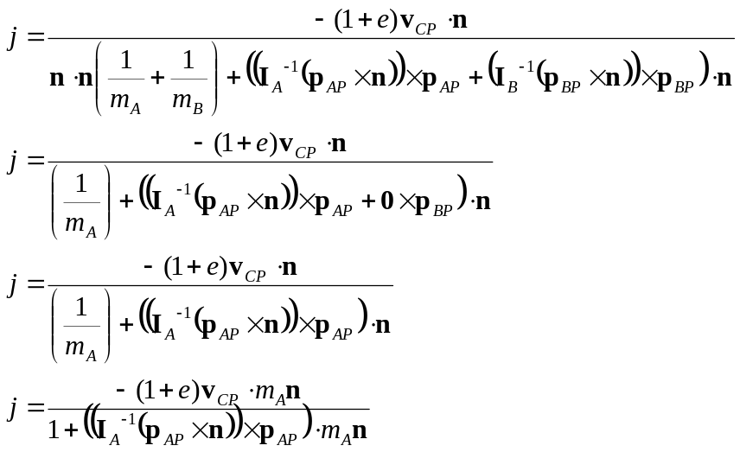

Where
e is the coefficient of restitution of the object
m is the mass of the object
v_{CP} is the velocity of the colliding point
n is the normal of the colliding triangle
p is the position of the colliding point relative to the object
I_{CM}⁻¹ is the inverse of the tensor of inertia in world-space.

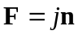

from which we can work out the torque:

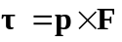

Additional forces can be added together at this stage as shown above, for steering and friction etc., so we end up with the quantities F_{T} and τ_{T} for the total force and torque exerted on the object.
Now we have the forces, torques and the impulse magnitude, we can use them to modify the linear and angular accelerations and perform the integration.

Next, we perform the integration over the time interval h since the last tick:

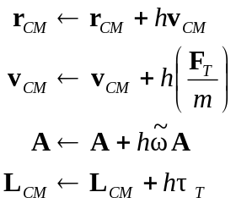

Next we re-orthogonalise the orientation matrix A:

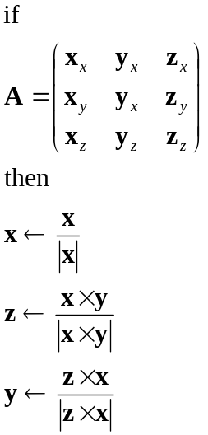

and finally reconstruct the inverse world-space moment of inertia tensor and use it to get the new angular velocity:

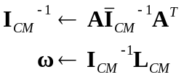

Miscellaneous Modification
The above algorithm has problems with microcollisions – i.e. collisions due to the object remaining in contact with the ground. Owing to the discrete nature of the model, microcollisions alone are not sufficient to pull a ‘balancing’ object back to the ground. Therefore, we directly modify the angular velocity of the object in RunPhysics to pull it to a horizontal configuration, where the criterion for horizontality is the normal of the triangle the car has just collided with, provided that the triangle is near-flat (i.e. has a large y-component in the normal).

This is done by taking a normal (0,1,0) vector and rotating it by the orientation matrix of the object, so it is now in world orientation. It now, therefore, points in the ‘up’ direction of the object. We then cross this vector with the normal of the triangle. The resulting vector will be the axis around which we need to rotate the object normal (and thus the object) to bring it closer to the triangle normal, and its magnitude will be proportional to the difference between the two normal vectors.

Since the angular velocity is also an axis/angle vector representation, we simply need to add some factor of this new vector to the angular velocity of the object to get the effect we want.

Collision Recovery: The Recover Function
Since impulses do not produce quite enough force to resolve all collisions, there needs to be an extra phase for resolving the condition where a previous impulse has failed to move an object out of collision. This case is detected in MovementTick, and in this case the Recover routine is called.

Recover takes a collision item, and attempts to move the primary object in that collision item out of collision by moving it along the normal of the colliding triangle until it is out of collision,in which case the recover phase ends; or until the colliding triangle changes, in which case it begins to move the object along the normal of the new triangle:

Vector line = normal of currently colliding triangle
Vector startpos = position of object

for(counter=TIMESTEP ;; counter+=TIMESTEP)
{
pos = startpos+line*counter
move object to pos
if not colliding, break out of loop

if colliding triangle has changed
{
startpos = pos
counter=0
}
}

Car Wheel Forces
In addition to the collision and microcollision forces which act on the car, there is a system of forces acting on each wheel, illustrated in the following diagram:
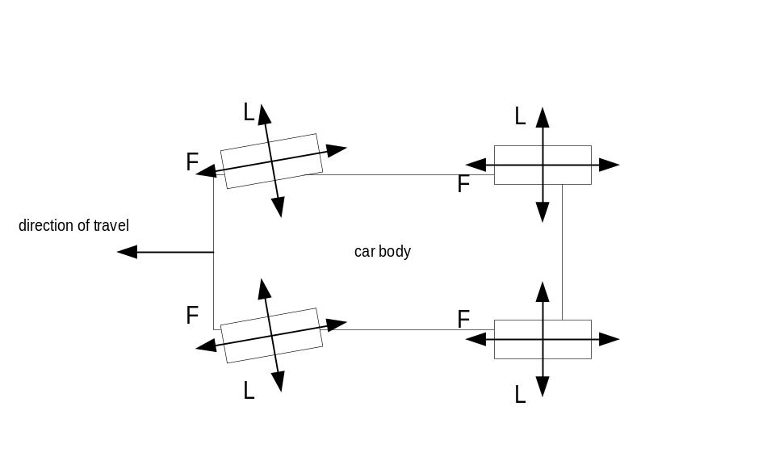As can be seen, each wheel has a set of forces acting on it: the F subset acts in the direction the wheel is pointing, and the L force acts in the direction at right angles to the wheel direction.

Forward Forces

The F set consists of the following forces:
- F_{d}, the driving force, which only applies to the driving wheels, and moves the car forwards.
- F_{b}, the braking force, which only applies to wheels with brakes.
- F_{f}, the forward frictional force, which is very low and gradually makes the car stop.

If we define the vector W as being the direction in which the wheel is facing, we can define f_{d}, f_{b}, f_{f} as being scalar factors of this vector representing the various components such that

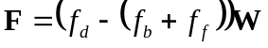

The driving force f_{d} is determined from the engine revs r_{e}. First we need to work out what the wheel revs r_{w} should be, which can be determined from the engine revs and the wheel ratio. From that and the driving wheel radius we can get a value for the linear velocity of the wheel assuming that it is sticking to the ground correctly. Given that r_{w} is in revolutions per second, and the radius of the wheel is w,

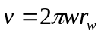

In order to get the magnitude of the force required, we need to get the acceleration required to get to this velocity. If we assume that if the integration interval is h and we’ll allow t sec to match the car velocity with the wheel velocity,

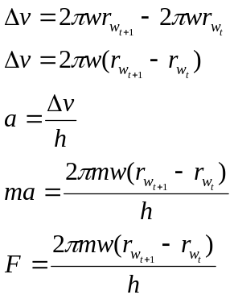
The L force is a frictional force acting at right-angles to the wheel. In accordance with Coulomb friction, the force varies discontinuously with the lateral force being exerted on the wheel by the ground; this can be calculated from the velocity of the car and whether the wheel in question is in contact with the ground.

For a low lateral velocity, where the car is not sliding, the frictional force is quite high – nearly enough to counteract the lateral drift. However, as the lateral velocity increase, a threshold is crossed as the car “loses grip” and the frictional force suddenly drops.

Therefore, given the definitions above and also that j is the magnitude of the force of the ground acting on the wheel (which will be a factor of the lateral velocity and degree of contact) and U is the up direction for the wheel,

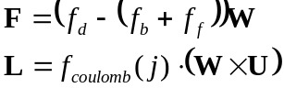

where f_{coulomb}(j) is a function which generates the discontinuity we require, which will be something along the lines of

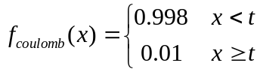 where t is a constant representing the threshold

This frictional force is also dependent on the forward velocity of the car – the faster the wheels are spinning, the less lateral friction there will be.

